Server Migration For IntelliBid / JobTrac and Surecount (In Red)

**On The Old Server:**

**NOTE – Ibid and JobTrac share the same Db and Repository, so no need to move anything extra for JTrac.**

**NOTE: The default SA password for SQL is C0nest32! (Capital C and number zero)**

**\*\* Before Starting - Check to see if the databases live in a Standard (Full) Version of SQL versus the SQL Express version (10 Gig Db size limit) that comes with the program. If they do, then you will need a Standard (Full) version of SQL on the new server \*\***

1. First, you need to make a full database backup of the IntelliBid SQL Database(s). The default database name for IntelliBid is CE_DATA, but could have been named anything when created. (You may have more than one database and will need to backup each separately).
2. Log into SQL Management Studio (Enter sa for the Login ID C0nest32! (Capital C and number zero) as the password ensuring the proper SERVERNAME\CONEST (Or whatever else the instance may have been named) is chosen in the “Server Name” field.

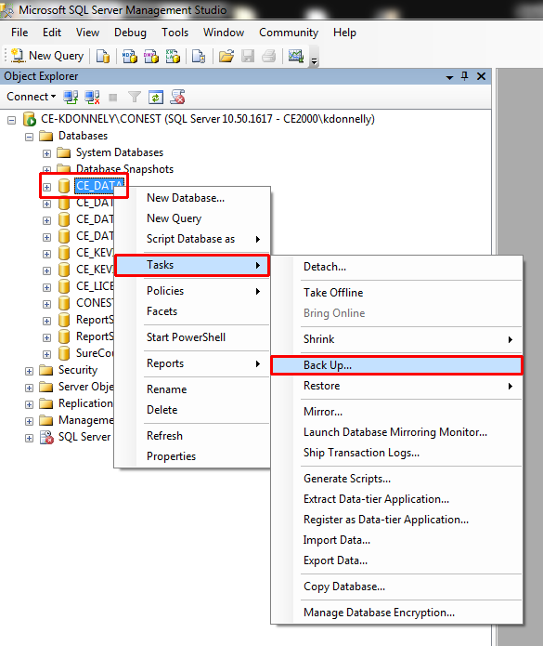Click the Plus sign next to Databases to drop-down the list of databases and ‘Right Click’ the database name (CE_DATA) and then choose ’Tasks’ and then ‘Backup’ (You will also need to follow this for the CE_LICENSE database and any other databases they may use for IntelliBid).

With the Add button at the bottom right of the Destination section navigate to the destination where you want the backup of the database to go (Or just Keep the default SQL Backup Folder listed below) and click ‘Ok’ to start the backup process. **NOTE:** The backup folder default location for a SQL2008 instance is C:\Program Files\Microsoft SQLServer\MSSQL10_50.CONEST\MSSQL\Backup. The backup folder default location for a SQL2012 instance is C:\Program Files\Microsoft SQLServer\ MSSQL11.CONEST \MSSQL\Backup.

When it is finished and says it completed successfully, click OK to close.

1. You will also need to perform this same procedure to backup the IntelliBid License database (CE_LICENSE) as well as any other databases you use for IntelliBid.

**On The Old Server (Cont.):**

You will also need to perform this same procedure to backup the IntelliBid License database (CE_LICENSE) as well as any other databases you use for IntelliBid.

**\* NOTE: If you also use SureCount, you will need to backup the “SureCountDB” database as well to move over.**

**\* NOTE: If you plan on upgrading Surecount to the latest V5 from any prior version you will need to call tech support for help upgrading the database and the clients once you get the backup of the SureCountDb and SureCount Drawing Folder moved from the old server to the new server. We would need access to each client to complete this.**

You should now have a CE_DATA.Bak and a CE_LICENSE.bak that you will need to copy to the new server, as well as any other database names.bak. Once you load SQL on the new server, you will need to put them in the SQL Instance’s Backup folder on the new server.

**NOTE:** You will also need to copy the entire Repository folder to the new server in the same location. Or any other location share accessible by the client systems (It will need to be shared out with EVERYONE – Read + Write on the new server for the client’s software to access it)

To find out where the location of the Repository folder is on the old server do the following: Open the SQL 2008 / 2012 (Whichever is applicable) Management Studio and run the following query against the CE_DATA IntelliBid SQL Database:

SELECT DISTINCT FileLocation FROM GEN_PREF

(The example below shows you that the location is C:\Conest Repository)

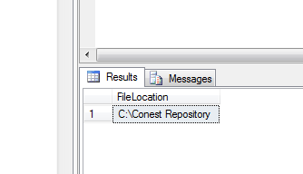

You would then copy that entire folder over to the new server and put it in the same location.

**Note:** Again, the Repository folder will need to be shared out with ‘Everyone’ Read\Write on the new server.

**SureCount Users Will Also Need To Do The Following:**

**You would also need to copy the Surecount Folder (The default location is C:\) that has the Drawing folder within it from the old Server to the new Server in the same location. To find out where the SureCount Drawing Folder is located on the old server go into the SureCount Admin Utility on a client machine and click on “Network Drawing Path” on the left. This will tell you where on the Server the Drawing folder is located. The Surecount folder would need to be shared out with ‘Everyone’ Read\Write on the new server, just like the Repository folder.**

**\*\* Give Tech Support a call with any questions or issues. 603-437-9353 X2 Mon thru Fri 7:30 AM to 6:00 PM EST**

**On The New Server:**

**\*\*** First download the IBFull.exe File from the ConEst Website (This will be the latest released version of IntelliBid). If you aren’t currently at the latest version and don’t want to upgrade to it at this time then call ConEst Tech Support and we can connect in and get the proper install files for that version downloaded to you  **(If you are a Surecount user you will also need the proper SCSetup.exe file)**

1. Double-Click the IBFull.exe file to run it, Let it create the C:\Repository\Install Folder for the IBLoader.
2. Click on “Full Install”.

SQL will load first, this will create a CONEST instance for the databases to live in and will create an SA Password of C0nest32!. **You will need to reboot the Server before proceeding.**

1. About a minute after the reboot, you should see the IBsetup start to load the client, just click Next thru it taking the defaults. You will then see it load the Client Tools.
2. When it’s complete, say No to the “Create a new database?” question and close down the Install Window. To load Surecount, double-click the SCSetup.exe and take the defaults to load the program. The databases (If you aren’t restoring) are loaded in the software programs respective Admin Utilities that come with the client install.
3. Perform the following steps to get the databases restored from backup:
4. Now that your 2012 SQL Express Instance is installed, put all the Backups from the old server in the following backup folder on the new server. C:\Program Files\Microsoft SQL Server\MSSQL11.CONEST\MSSQL\Backup
5. You will need to go into SQL Management Studio 2012 and log into the instance you created on the new server, again using sa for the Login ID and C0nest32! (Capital C and number zero) for the password.
6. Right-click on “Databases” on the left and click on “Restore Database”
7. In the box that pops up, in the “Source for resource” section choose the “From Device” radio button and hit the button with 3 dots at the end of that field.
8. Click the “Add” button and in the box that opens you should see the CE_DATA.BAK and CE_LICENSE.BAK files you put in the backup folder as well as any other Db Backups you may have moved from the Old Server. Choose the first backup in the list and click OK then Click OK again. **\* If Applicable, Restore the SureCountDB from backup as well.**
9. In the “Select the backup sets to restore” section, put a checkmark in the empty box under Restore. In the “Destination for restore” section above, use the drop-down arrow at the end of the “To database” field and choose the same database name as the name of the database you’re restoring from backup. IE - if you chose the CE_DATA.BAK choose CE_DATA from the list.
10. On the left, choose “Options” and under “Restore Options” select “Overwrite the existing database (WITH REPLACE).
11. Click “OK” and you should see the database restore 10% at a time, when it pops up with Restore Completed Successfully box click OK and the windows should close. **NOTE:** You will need to follow steps C) thru H) for each database backup you moved over from the old server.
12. Still in SQL Management Studio, we need to create the ConEst user that will be the owner of each Db and make the ConEst User the owner of each Db:
13. On the left, hit the plus sign next to “Security” (Not the Security under each db’s Drop-down but the folder down past all the Dbs) to expand it and Right-Click on “Logins” and choose New Login.
14. In the Login Name field type in ConEst as the login name and then choose the “SQL Server Authentication” radio button.
15. Type in the password C0nest32! (Capital C and number zero) as the password and confirm it. Uncheck “Enforce Password Expiration” which will also uncheck “User must change password at next login”.

**On The New Server (Cont.):**

1. On the left (Still in the Login Properties – ConEst box) choose “Server Roles” and ensure that BulkAdmin, ProcessAdmin, and Public are all checked on (all have a checkmark). Click OK.
2. (Still in SQL Management Studio) Lastly you need to right click on each database you restored from the backups and make the ConEst User you created the owner of the database:
3. For “Databases” on the left, hit the plus sign to expand out the list of Dbs (if it’s not already expanded out). Right-Click on the first restored Db and choose “Properties”.
4. In the “Database Properties” box that opens click on “Files” on the left.
5. At the end of the “Owner” field on the right, click the button with the 3 dots. In the “Enter the Object Names To Select” box type in ConEst and click “Check Names”. There should now be a bracket around the ConEst name you entered. Click “OK”. Click General on the left and you should see the Owner is ConEst. **NOTE:** You will need to do steps a), b) and c) for each database you restore, including CE_LICENSE.

**SureCount Users Will Also Need to Do The Following:**

**Follow Steps 1 thru 5 above, only in Step 2, instead of typing in ConEst as the login name, type in SureCountDBUser as the login name. In Step 3, type in Surecount32! as the password and confirm it.**

**For Step 5, Right-click on the SureCountDB and make the SureCountDBUser the owner of the Db by following steps 5a) b) and c). On Step c) type in SureCountDBUser (Instead of ConEst from above) and click “Check Names”. Follow the rest of C)**

1. You will need to open up TCP-IP Port 1433 and UDP Port 1434 Inbound and Outbound on the Windows firewall to allow the program. **NOTE:** Windows products block ports 1433 and 1434 by default whether the firewall is turned on or off.
2. Find and access “Windows Firewall with Advanced Security” on the new Server.
3. First, create a new Inbound rule for TCP IP Port 1433 to allow it thru, then create a new Inbound rule for UDP port 1434 to allow it thru. Next, create a new Outbound rule for TCP IP Port 1433 to allow it thru and lastly, create a new Outbound rule for UDP Port 1434 to allow it thru.
4. On the new Server open the Microsoft SQL Server 2012 “SQL Server Configuration Manager”
5. On the left, click into “SQL Server Network Configuration”
6. On the right, double-click on “Protocols for CONEST” (If you changed the instance name to something other than CONEST during the SQL install then choose that one instead).
7. Ensure that “Named Pipes” and “TCP/IP” protocols are both Enabled, If not then right-click on each one and choose “Enable”. Click Ok to the “Any changes made will be saved; however, they do not take effect until the service is stopped and restarted.” message.
8. Double-click into the TCP/ IP protocol and choose the IP Addresses tab.
9. Scroll down to the IPALL section at the bottom. If there is a number next to “TCP Dynamic Ports” highlight it and delete it so that it is blank. For the “TCP Port” field, change whatever is there to 1433. Click OK to close.
10. On the left, click into SQL Server Services and on the right highlight the “SQL Server (CONEST) (Or anything else you may have named your instance during the install). With it highlighted, click the button on the toolbar that says, “Restart Service”. After the service has restarted shut down the Configuration Manager.

**On The New Server (Cont.):**

On the new Server, You will then need to go to the ConEst Admin Utility to delete the connection to the old SERVER\INSTANCE\DATABASE(s) and make a new connection to the new SERVER\INSTANCE\DATABASE(s).

Delete Old Server Db Connections:

1. Open up the Conest IntelliBid Admin Utility
2. On the left choose “Connection Maintenance”
3. On the right, Click the “Delete A Connection” radio button. Choose the first Old Server Db path and hit the delete button. If there are more than one Db then delete each one.

Add New Server Db Connections:

1. In the Admin Utility, on the right side of the Connection Maintenance, Click the “Add A Connection” radio button.
2. Click the button with the 3 dots at the end of the Server Field and in the “Browse for SQL Servers” box that opens, choose the new SQL Server\Instance name and click OK.
3. Then login to that instance with the ConEst User password – Which by default is C0nest32! (Capital C and the number zero)
4. Click the “Connect” button and choose the database you want to add the connection to and click the “Add Connection” button.

NOTE: If you need to connect to more than one database you will need to follow steps b) thru d) and add each database connection separately.

You will also need to get all the client machines pointed at the new Server’s db Connection(s) by following the “Delete Old Server Db Connections” steps then “Add New Server Db Connections” steps on each client machine.

**\*If you have SureCount, you will need to go into the SureCount Admin Utility and change the connection to the new SERVER\INSTANCE\SureCountDB, as well as make sure that the Network Drawing Path is set to use the UNC network path where you out the Surecount Drawing folder.**

** The last step is to call ConEst Tech Support at 603-437-9353 X2 Mon thru Fri 7:30 AM to 6:00 PM EST

for the License Transfer and Activation on the new server.

* **NOTE**: If you run into any issues during the transfer give Tech Support a call for assistance.