Epic Pricing Update for IntelliBid
When using Epic, there are a few configuration options that need to be set before you can update IntelliBid.
The first step is to run the Epic Setup process in IntelliBid. Maintenance/Items/Tra-Ser/Epic Setup.
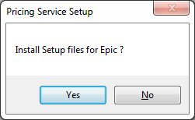
Next, open Epic and from the menu select Options, then Set Epic Link.
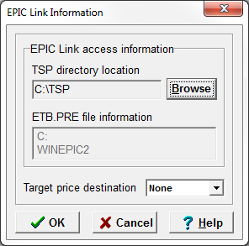
Make sure the information matches the above. In the Target price destination there are 5 options:
The only options used for updating IntelliBid are None and Col 3. Each option needs to be created separately.
Target price destination = None updates the Trade/3 – COL
Click ok
Click on options
Update manager
Properties
Make sure your settings for Conest are as follows then click ok then update
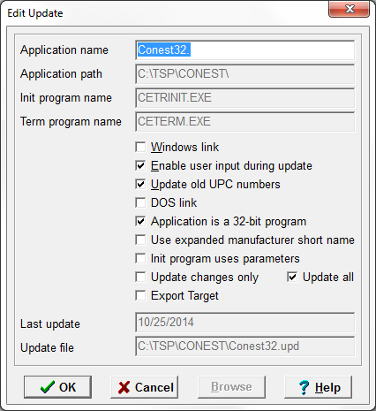

Open Intellibid ; you will get the following notification
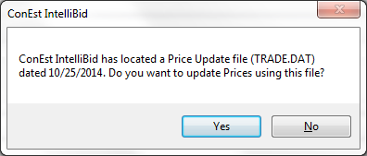
Click yes
After the update is complete a report will be generated; you can close it
And then you will get a message that the Tra-ser update is complete (it really means Epic ;))
Click ok
Click yes to the delete .dat file?
Trade/3 Col has been updated; close IB and go back into Epic and follow the process below to update Target
Options > set Epic link
Choose Col 3 and click ok
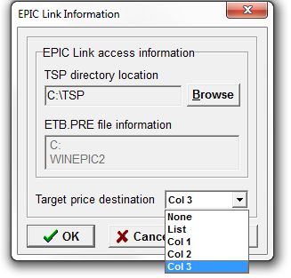
Click options > update manager > update
Target price destination = Col 3 updates the Target Column.
The Target column update is run the same as the one for Tra-Ser.
After the update click close and open IB
You will get the following message; click NO
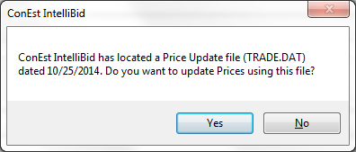
Go to Maintenance/Items/Vendor/ Select the Target column in the upper grid, then under the import section, select From Target Import File. Then select the Import to Vendor Selected in Grid.
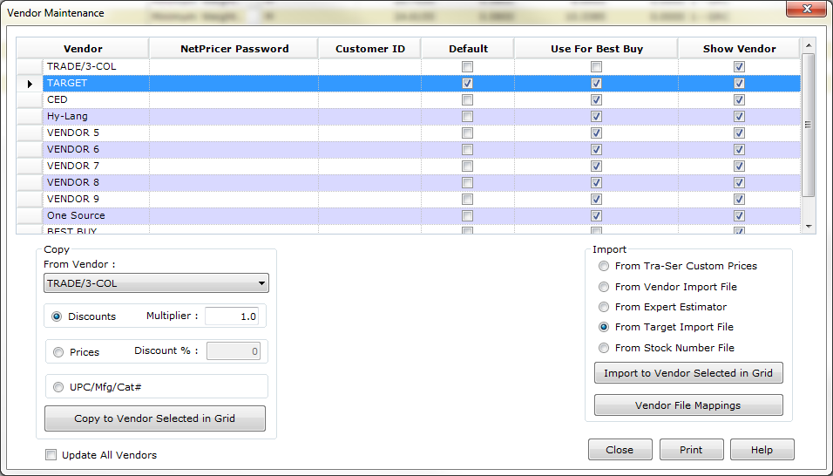
Delete the .dat file after the update is completed.
To link items from Epic into IntelliBid, a few changes need to be made: From Epic select Options then Epic clipboard formats. Make sure: Extended clipboard format and Header in clipboard format options are checked.

To export items, check the box next to the item to be exported by double clicking the box to the left. Then left click the Copy item to clipboard option.
In IntelliBid Item Maintenance, locate where the new item is to be placed and right click Paste append or Paste insert.

